**Instructions for joining the RStudio workspace for today’s workshop**

1. Create a free account here:  <https://rstudio.cloud>
2. I have created a workspace for today’s workshop which is accessible from RStudio Cloud. Copy and paste this URL in your browser: <https://rstudio.cloud/spaces/94223/join?access_code=DISbtNdlW5nczXtPOtw6fjvwyVNqLjlTatHv%2Ffrt>
3. Join the workspace.
4. After you join you will see the following welcome screen. It is devoid of any instructions for the next steps to take!

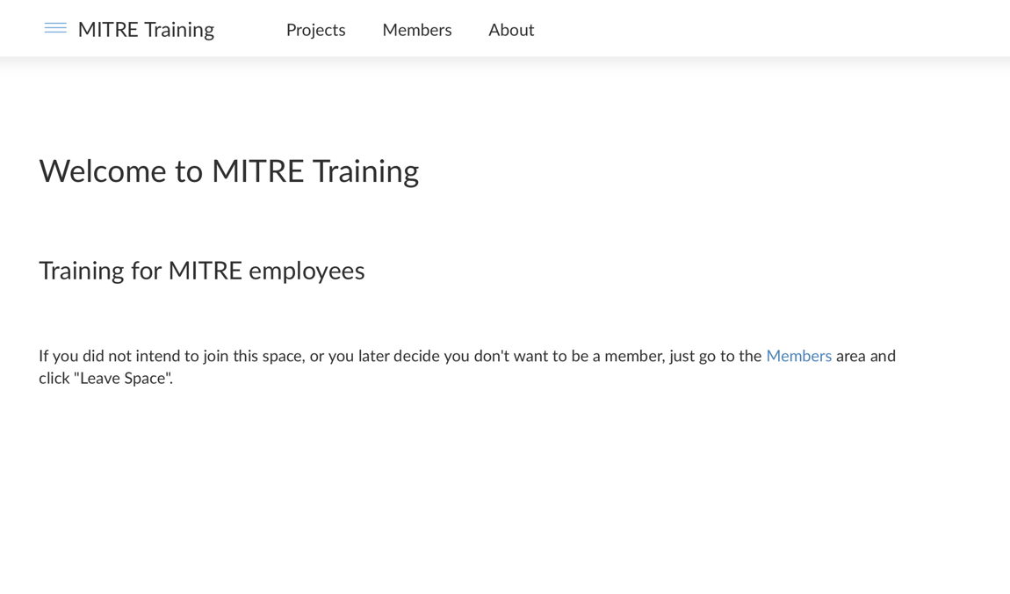

1. Click on the “Projects” tab in the top menu bar, which will bring you to the project we will use today.

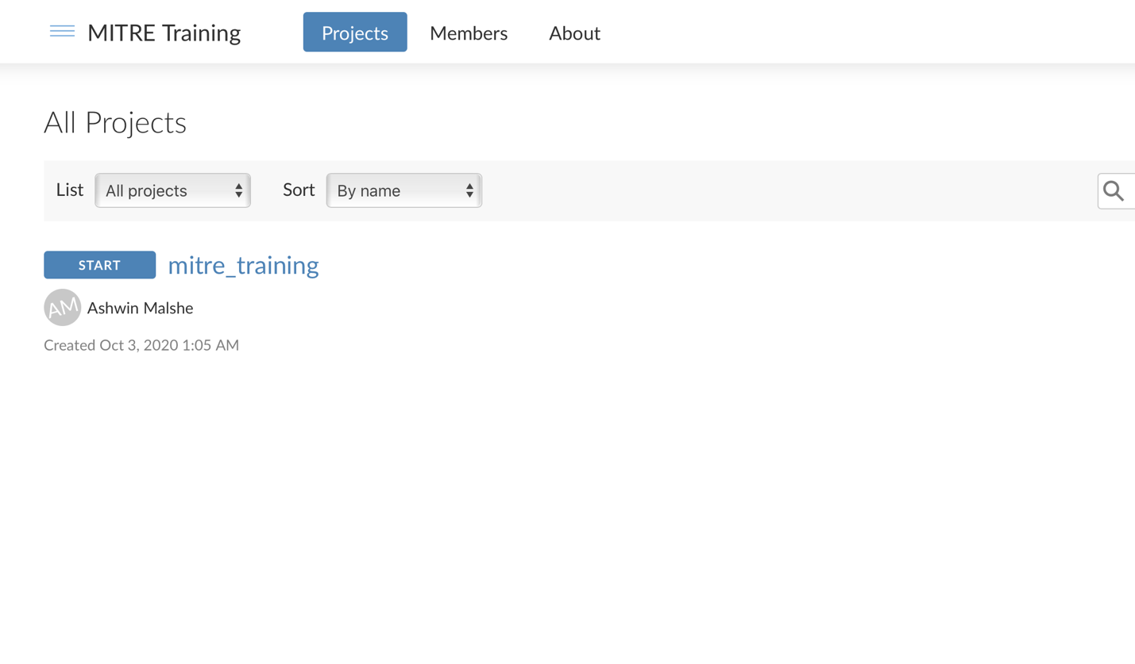

1. Start the project. You are now inside the project for today’s workshop.